**Biostatistics HW 7**

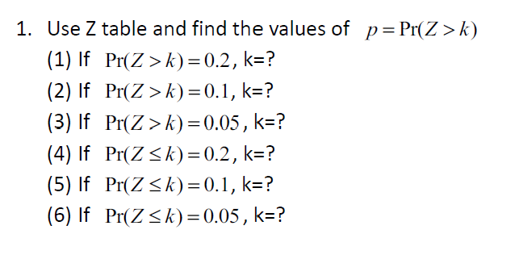

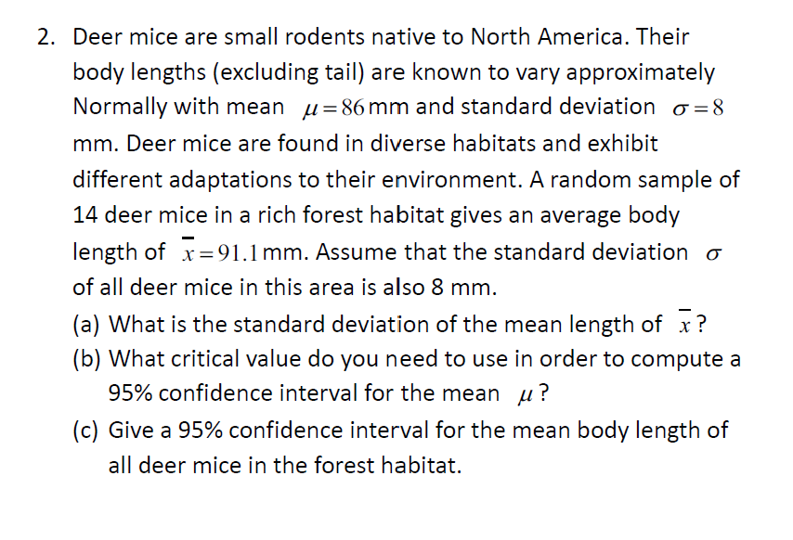

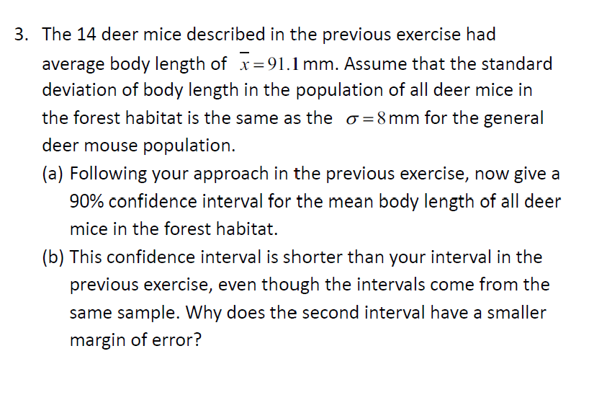

4. You are planning a survey of starting salaries for recent marketing majors.

In 2005, the average starting salary was reported to be $38000 (美金).

Assuming the standard deviation for this study is $10,500.

What sample size do you need to have a margin of error equal to $900 with 95% confidence?

5. Finding critical t∗ values.

What critical value t∗ from T-Table should be used to construct

(a) a 95% confidence interval when n = 12?

(b) a 99% confidence interval when n = 24?

(c) a 90% confidence interval when n = 200?

Note: , where  is the confidence level.

6. 做 (a) (c)

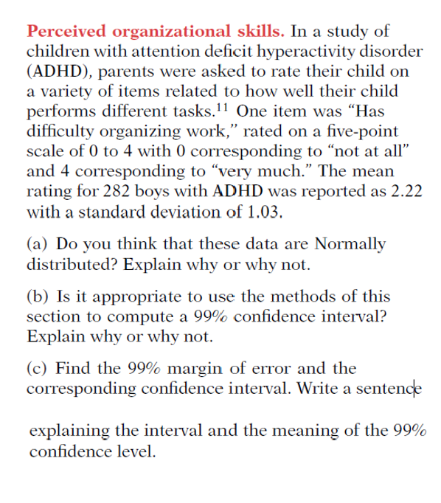

Note: (b) 本來 five-point scale 0-4 不適宜用 t 分配 (因為 t 分配需要 normal 假設), 但是n = 282 樣本大, 所以 t confidence interval 仍可以做為近似